**Lab02**

Iftekhar Al-Mahmud

ID: 20201120  
Section: 01

**Outputs of different packet sizes:**

**Packet Size:128**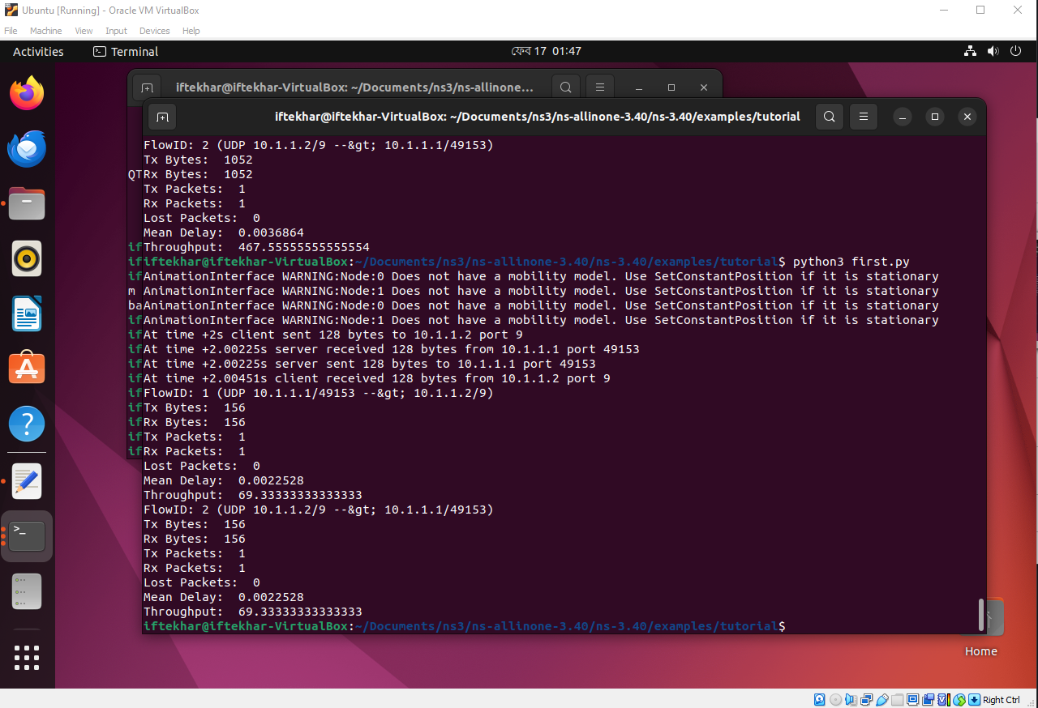

**Packet Size: 256**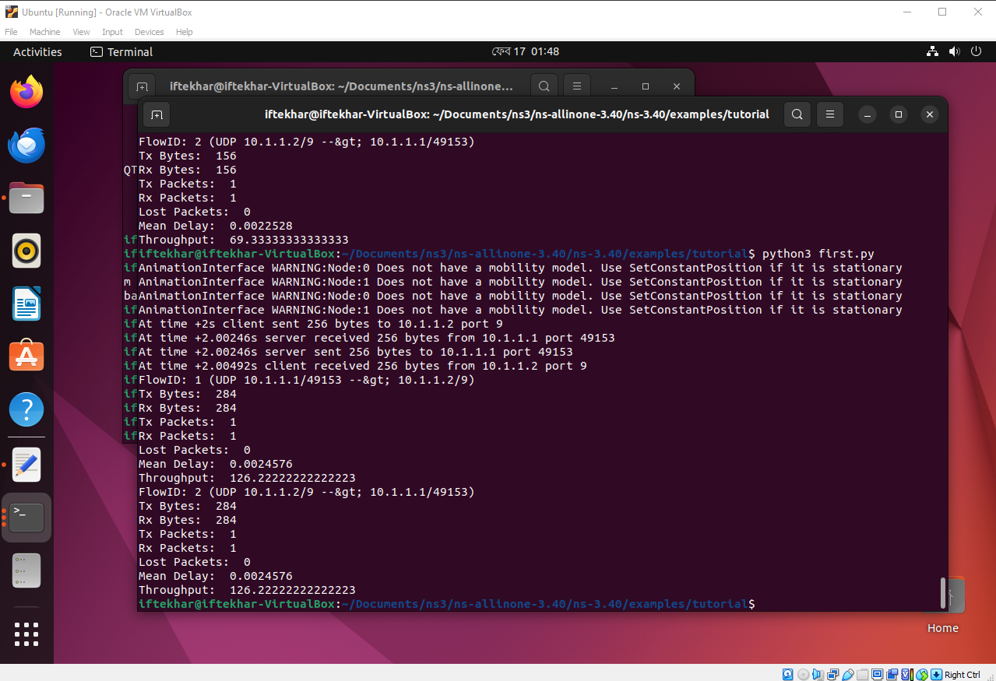

**Packet Size: 512**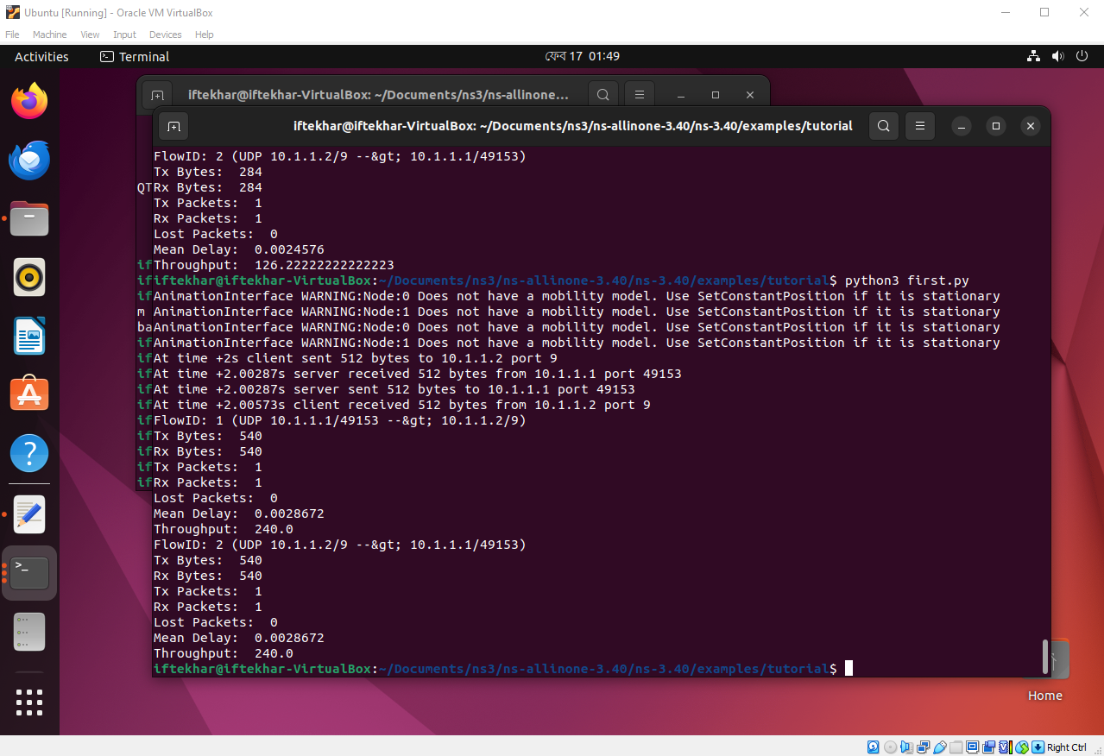

**Packet Size: 1024**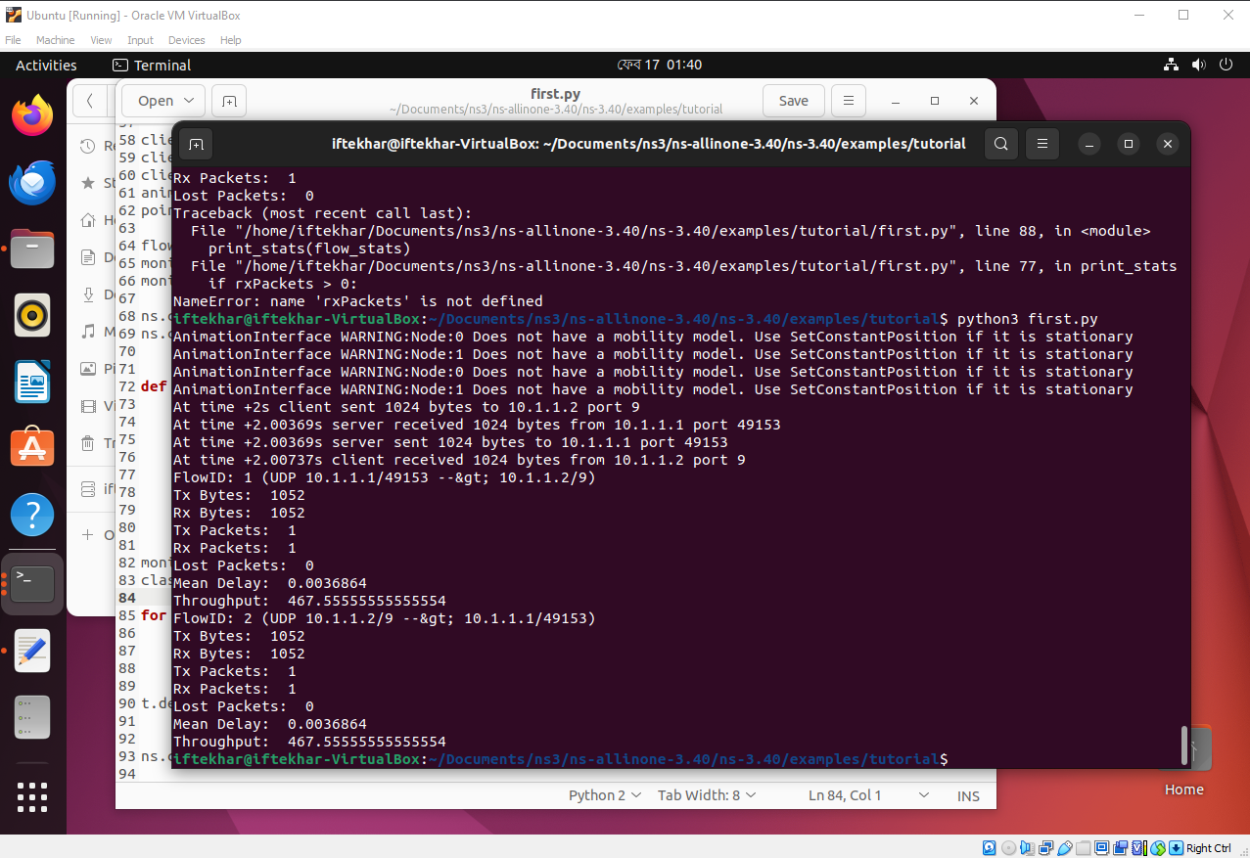

**Packet Size: 2048**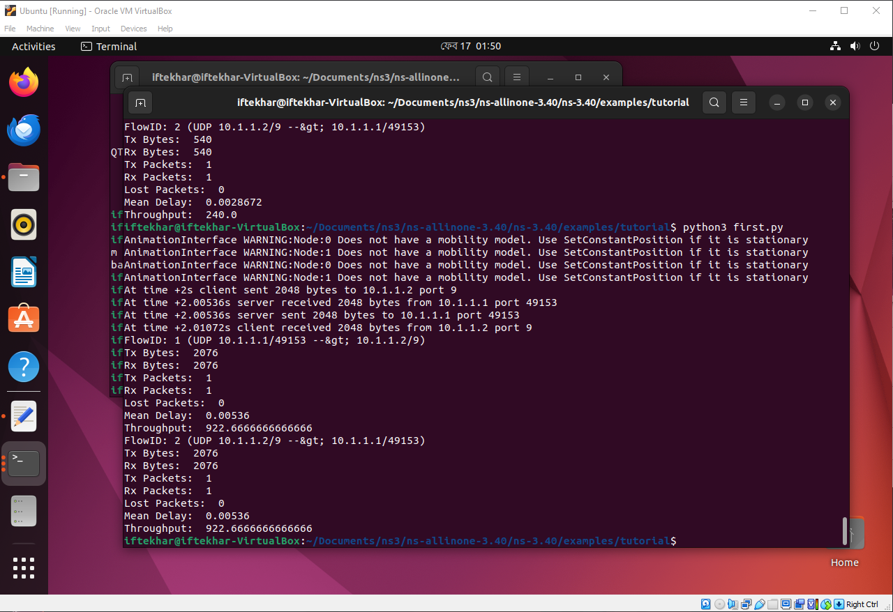

**Packet Size Vs Throughput**

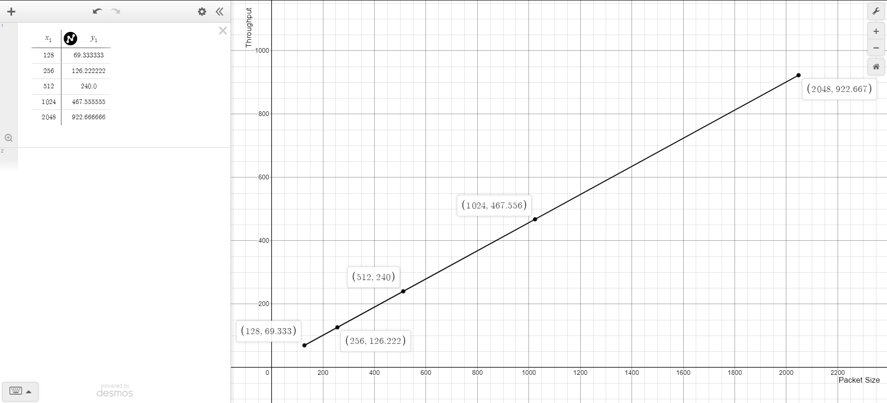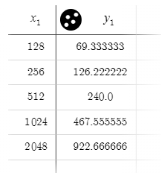

**Description:** As Packet Size increases the throughput increases generally. The graph does not exactly follow a straight line instead, it curves upward so the relationship between Packet Size and Throughput is not exactly linear. From the graph we can see that beyond a certain value of packet size the increment of throughput becomes a bit less. Also from the graph we can say that the maximum throughput lies between the packet size 512 and 1024.